**Start/ Stop Raise a general query request**

**Start/ Stop VM after use. Each VM is budgeted to be run for 80 hours.**

**Do not make any changes to VMs of other particiapnts.**

Portal link - <https://portal.azure.com/#home>

**Steps to start/ stop VM**

1. Click on virtual machines

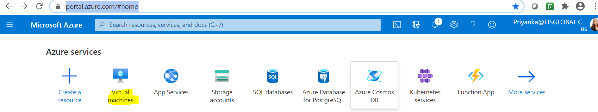

1. Select your VM ID

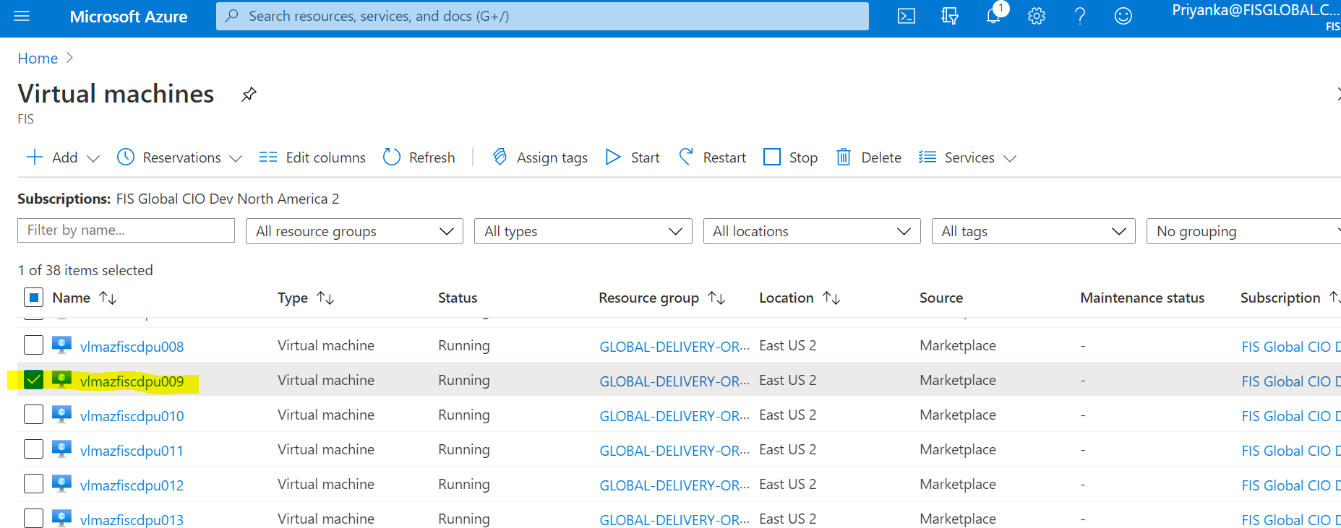

1. Click on start / stop as required

